**SPFx Webpart with @pnp Controls and @pnp SP library**

**Create a SharePoint List**

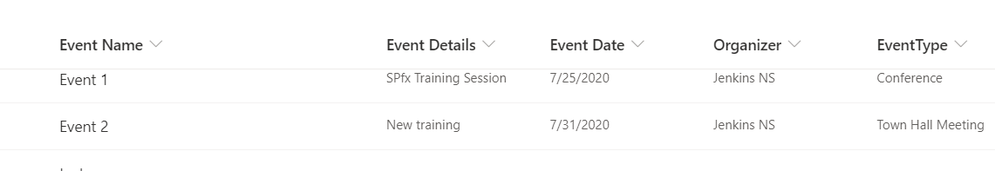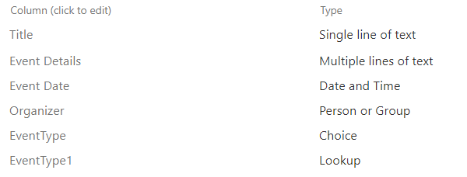

**Create a new web part project**

* Navigate to your favourite folder
* create new folder
* move to newly cerated folder
* Open Command prompt and run following comment to create a new web part by running the Yeoman SharePoint Generator
  + - yo @microsoft/sharepoint
* When prompted:
* Enter the webpart name as your solution name, and then select Enter.

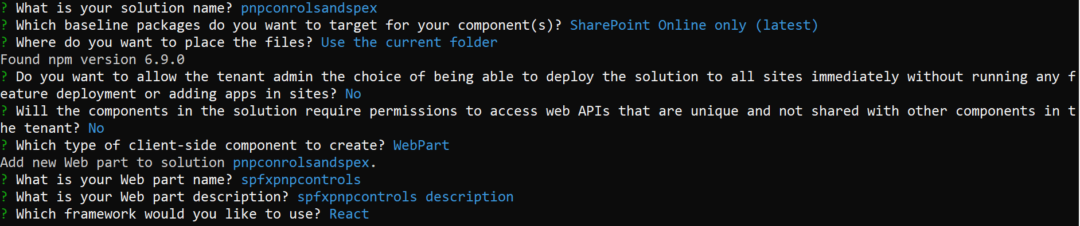

Install the library and required dependencies for pnp controls and library

* npm install @pnp/sp@2.9.0 –save
* npm install @pnp/spfx-controls-react --save --save-exact
* npm install moment –save

Open the project in visual studio code

* **code .**

Then open SpfxpnpcontrolsWebPart.ts file and add context:this.context in render method.

Then Navigate to .\srcwebparts\spfxpnpcontrols\components\ISpfxpnpcontrolsProps.ts

Add context

import { WebPartContext } from "@microsoft/sp-webpart-base";

export interface ISpfxpnpcontrolsProps {

  description: string;

  context:WebPartContext;

}

Create a new file to manage state ISpfxpnpcontrolsState.ts under components folder .\srcwebparts\spfxpnpcontrols\components\ and add below code

import { IViewField } from "@pnp/spfx-controls-react/lib/ListView";

export interface ISpfxpnpcontrolsState {

  items: any[];

  viewFields: IViewField[];

}

Navigate to .\srcwebparts\spfxpnpcontrols\components\ Spfxpnpcontrols.tsx file

Import below headers

import { ISpfxpnpcontrolsState } from './ISpfxpnpcontrolsState';

import { ListView, IViewField, SelectionMode, GroupOrder, IGrouping } from "@pnp/spfx-controls-react/lib/ListView";

import { sp } from "@pnp/sp";

import "@pnp/sp/webs";

import "@pnp/sp/lists";

import "@pnp/sp/items";

import * as moment from 'moment';

extends below interface in the class

ISpfxpnpcontrolsState

Add a variable to handle ListView Control columns first line of the class

Private _viewFields: IViewField[] = [

      {

        name: "ID",

        displayName: "ID",

        isResizable: true,

        sorting: true,

        minWidth: 0,

        maxWidth: 50

      },

      {

        name: "Title",

        displayName: "Event Name",

        isResizable: true,

        sorting: true,

        minWidth: 0,

        maxWidth: 150

      },

      {

        name: "EventDetails",

        displayName: "Event Details",

        isResizable: true,

        sorting: true,

        minWidth: 0,

        maxWidth: 100

      },

      {

        name: "EventDate",

        displayName: "Event Date",

        isResizable: true,

        sorting: true,

        minWidth: 0,

        maxWidth: 100,

        render: (item: any) => {

          const created = item["EventDate"];

          if (created) {

            const createdDate = moment(created);

            return <span>{createdDate.format('DD/MM/YYYY')}</span>;

          }

        }

      },

      {

        name: "Organizer.Title",

        displayName: "Organizer",

        isResizable: true,

        sorting: true,

        minWidth: 0,

        maxWidth: 200

      },

      {

        name: "EventType",

        displayName: "EventType",

        isResizable: true,

        sorting: true,

        minWidth: 0,

        maxWidth: 100

      },

      {

        name: "EventType1.Title",

        displayName: "EventType1",

        isResizable: true,

        sorting: true,

        minWidth: 0,

        maxWidth: 100,

      }

    ];

Then add constructor

constructor(props: ISpfxpnpcontrolsProps, state: ISpfxpnpcontrolsState) {

    super(props);

    sp.setup({

      spfxContext: this.props.context

    });

  }

    this.state = { items: [], viewFields: this_viewFields };

    this._getLists();

  }

In render method replace div container to below code

<ListView

          items={this.state.items}

          viewFields={this.state.viewFields}

          compact={true}

          showFilter={true}

        />

Add one private method to get lists items

  private async _getLists() {

    const allItems: any[] = await sp.web.lists

      .getByTitle("SPFxEvents")

      .items

      .select("ID","Title","EventDetails","EventDate","EventType","Organizer/Title","EventType1/Title")

      .expand("Organizer","EventType1")

      .top(100)

      .filter("(Title ne '')")

      .orderBy("Title")

      .usingCaching()

      .get();

    this.setState({ items: allItems });

  }

